***HOUSATONIC CAMERA CLUB NEWSLETTER* February 2012**

**MEETING TIME….**

The Digital Circuit cds have arrived! Last summer we sent in a number of photos in the Open and Nature categories of the NECCC Digital Circuits. Our photos were combined with those from several other clubs and then all were sent to an NECCC expert commentator who evaluated them and made suggestions for possible improvement. The resulting cds for each category were then sent out to the participating clubs. We will feature one at our next club meeting on Tuesday, Feb. 21, at Noble Horizons in Salisbury, CT. Come see what one expert had to say and see if you agree. Looking at and discussing photos in this manner can be a great learning experience and can help us look at our own images in a new light.

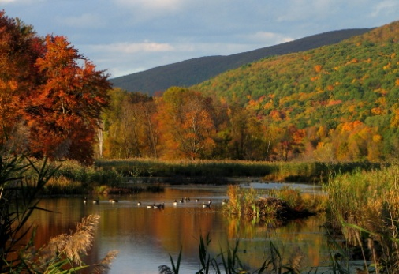In addition, at the February meeting we will take time to review the images that a currently on exhibit as part of our Noble Horizons Show. If you haven’t seen the show, this will be a great time to view it. We have received many compliments on our work.

***************************************************************­

*Show reminder: If you have pictures hanging in the show, please send digital images of each to Lazlo so he can add them to our Noble Show 2012 file on the Forum.*



**COMPETITION TIME**….

The results of the most recent competitions have not been received yet, but it is already time to start sending in images for the next round of judging. Pictures for PSA should be sent in *now.* The deadline for submission of three images to the website is Feb. 18, and voting will take place from Feb. 19 to Feb. 25. Send your photos to Lazlo [lazlo1@optonline.net](mailto:lazlo1@optonline.net), and he will add them to the PSA competition folder. Make sure you size your files to no larger than 1024 pixels wide x 768 pixels tall. Vertical images must be no taller than 768 pixels. Files should be saved as jpegs and be no larger than 350k. Files should be named as follows for PSA:

3-Housatonic-FirstLastName-Title of the Picture.jpeg

NECCC images need to be posted to the website (or emailed to Lazlo) by March 17th.   Judging will start on March 18th and end on March 31st.  The new NECCC rule for labeling is that you just need to put your first name last name and title.jpeg.  No need to rename with a P or N or $ or_ anymore for NECCC, but when sending images to Lazlo, be sure to let him know if they are for the Nature or the Pictorial competition. The size requirements are the same as those for PSA.

*It is very important that you follow the size and title rules. If images do not meet the requirements they will not be accepted by NECCC or PSA. Every round, some images are incorrectly submitted causing more work for the competition coordinator and causing delays in sending in our final entries. If you have questions, contact Brian at* [ctphoto@comcast.net](mailto:ctphoto@comcast.net).

**

**CHALLENGE TIME….**

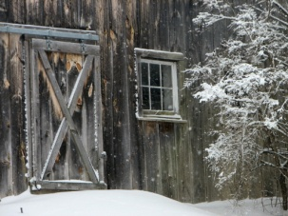It is also time to start sending in photos for some of the club photo challenges. The folders for the first two assigned topics, “Farms and Farming” and “Doors and Windows”, are being added to the Forum website so you can begin to upload images yourself or send them to Lazlo for uploading. Try to size them the same as you would for competitions. Folders for the other two topics, “Faces” and “The Color Green”, will be added in a month or two.

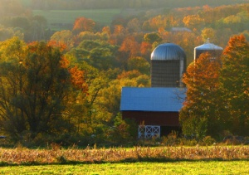Although we will be viewing and discussing these images at a future meeting, please also use the website to start making comments now. You can ask questions, or make suggestions on how you think a photo might be improved, or you can just note what you liked about a particular image. All positive comments are welcomed!

***LOOKING AHEAD-* FIELD TRIP TIME….**

We are currently planning a Camera Club field trip to the Livingston Ripley Waterfowl Conservancy in Litchfield, Ct. (<http://www.lrwc.net/>). The date has not yet been set, but it would help to know how many members might be interested in attending. If you are interested, please email Jane at [jross2@mail.com](mailto:jross2@mail.com). More information will be available at the February meeting. Also, watch your email for further details.

[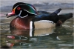](http://lazlo.us/coppermine_phpbb3_housatonic/displayimage.php?album=45&pos=5)

*LOOKING AHEAD-* **CONFERENCE TIME….**

Our club can apply for one free registration to next summer's New England Camera Club Council Conference which will be held at U-Mass, Amherst, Mass. on July 13-15, 2012 (<http://www.neccc.org/New_Outline_13.htm>). The complimentary registration gives the person submitted by our club all the learning experiences, photo opportunities and inspirational programs that go along with the conference. *Please note, that the enrollment covers only the registration fee. The recipient will be responsible for his or her own room, meals and transportation.*

**Rules governing the courtesy enrollment:**

1. Candidates must be at least eighteen years of age as of July 1, 2012.

 2. A candidate must be a member of an NECCC member Club in good standing (i.e. dues paid for the current year).

3. Candidates must have never attended a previous NECCC conference.

 4. Selection of the candidate will be the responsibility of the individual clubs.

 5. Club applications should be sent by email by March 1, 2012.

 6. The application cannot be transferred to another person. Once someone has been submitted, accepted and has received the key paper work, that person must register for the conference. If he/she cannot attend, another person cannot take his/her place. The club’s courtesy enrollment for that year will be forfeited.

***If you are interested in applying, let Jane know by February 20.***

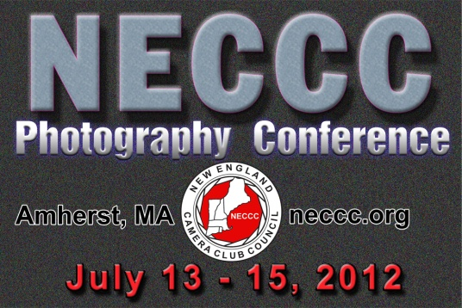

**HOUSATONIC CAMERA CLUB PROGRAM SCHEDULE 2012**

**February 21:** Digital Circuit DVD / Discuss Competition Images for PSA/ Review Noble Show

**March 20:** Presentation by Bill DeVoti, “Modern Croatia” / Discuss NECCC Competition Photos

**April 17:** Presentation by Fred Orkin, “A Trip to Belgian and Holland” / Discussion of Competition Images for PSA

**May 15:** Presentation by Joe Meehan, Subject T.B.A.

**June 19:** End of Year Dinner and Members Showcase / Assigned Topics Club Photo Challenges

Meetings are held in the Wagner Building at Noble Horizons in Salisbury, CT. starting at 7:00 pm. Guests are always welcome.

*****************************

***SPECIAL NOTE: We desperately need someone to help write and/or gather articles for the newsletter. Can you******contribute a short “how to” article, camera review, favorite photo website, book, or magazine suggestion, or a description of one of your favorite places to take photos? How about telling us about one of your favorite picture taking adventures? Please help if you can! Upcoming issues could be in jeopardy****.*